**Software Requirement Specification (SRS)**

**Project Title: Blood Bank Management System**

**Requirement:**

We need to build a software for blood bank. There are two internal users involved in this system. The user requirements are considered as follows:

* **Donor**
* **Administrator**

1. There will be different type users like Admin, Donor etc.
2. There will be different type blood group like A+, A-, AB+, AB-, O+, O-, B+, B-.
3. A donor check his/her donation summary.
4. Requested blood group list.
5. Total Blood donation list.
6. Who are interested in donating blood for the people.
7. The hospital can request blood via e-mail and by calling to the blood bank.
8. The system is able to generate a report to summarize all records including blood donation, blood requests and blood stock for the administrator.

**Analysis and Design Part:**

1. Brainstorming Diagram:

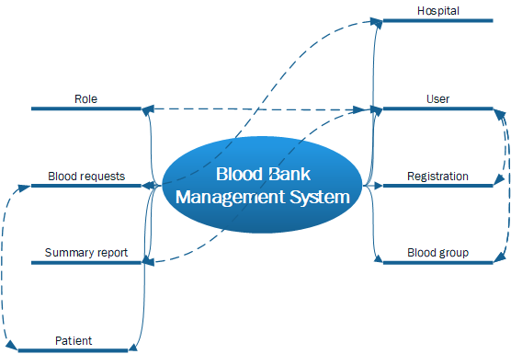

1. Use Case Diagram:
2. Class Diagram:
3. Entity Relation Diagram:
4. Front End Design: